**Cayuse Human Ethics Summary of Changes**

The Office of Research of Compliance is pleased that the TCU research community, a vital part of our institution, has received Cayuse Human Ethics so well since its implementation in January 2022.

Since its implementation, we have heard your constructive feedback and have taken all suggestions seriously. It is part of our mission to be a resource to facilitate human subject research on this campus. We ensure that our electronic submission system is user-friendly and can accommodate all the outstanding research conducted at TCU.

We have made some significant changes, and this document serves as a summary of those changes so you are aware of all the changes made to serve you better, confidently make the submission process a little easier, remove unnecessary questions, and ensure submissions are received with the necessary information.

Please pay attention to any text in blue; these are hyperlinks to various areas of our website, making it easy to access guidance documents, templates, and other helpful tools.

**Cayuse Human Ethics Summary of Changes: Fall 2024**

Please review the introduction page of the initial application. Our website, [research.tcu.edu](https://research.tcu.edu/research-compliance/irb/), now has new links to resources, guidance, and study start-up tool kits.

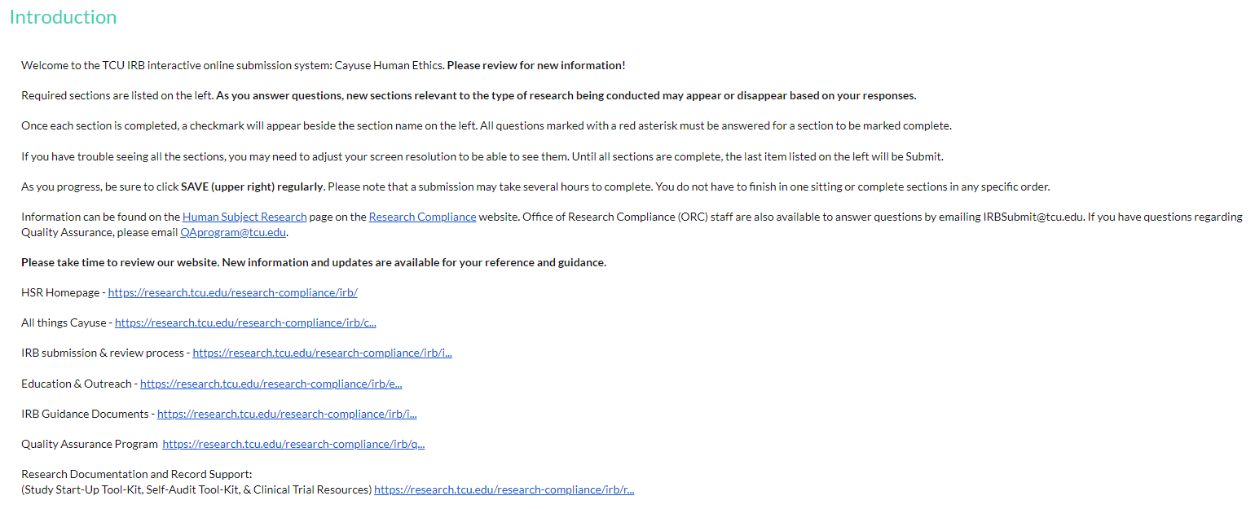

Next, the options at the bottom of the Submission Type page have changed. You will notice chart reviews are no longer an option on this page. You can submit chart reviews using the Exempt Determination or Research study options. Please read through the rest of the document to make yourself aware of additional changes to Cayuse.

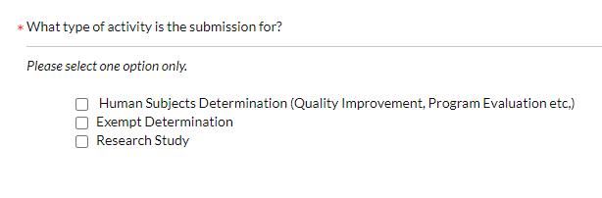

Previously, the option of *activities that do not constitute human subject research* was revised to **human subject determination**.

This section will now guide researchers through breaking down the federal definition of human subject research. The goal is to ensure and empower our researchers to know whether their project is human subjects research before completing and submitting the abbreviated application. As the questions are answered, you will have the following three determinations before you provide details about the project.

1. Not Research – the project does not meet the definition of research
2. Research- Not Human Subjects – the project would be considered research but does not involve human subjects
3. Human Subject Research – You must return to the submission type page and change your selection to Exempt Determination or Research Study.

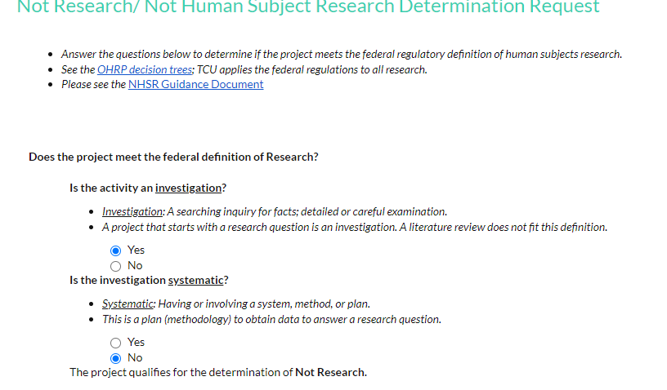

Many innovative researchers have often asked why it is necessary to complete the entire application for a study that needs an exempt determination. While the federal regulations may not fully apply to research determined to be exempt, plenty of caveats must be met to receive an exempt determination.

The Office of Research Compliance now offers a Guided Exempt Determination application to reduce the need to complete the same full application. **Please remember that the IRB ultimately decides if research qualifies for exemption.** Investigators can now make an initial determination by following the below instructions:

**Instructions for Guided Exempt Determination:**

1. Read All information at the top of the page.
2. Select all the appropriate exempt categories that fit the submitted research.
3. Work through the additional questions that will appear under each category.
4. If the research does not qualify for the exemption, the application will direct you to complete the full research application.
5. If the research does qualify for the desired exemption, the rest of the abbreviated application will populate.
6. Complete each section as you normally would. Ensure to answer every question in each section that applies to the research.
7. The review process will not change; if questions are unanswered or not answered sufficiently, the application will be sent back to the study team.

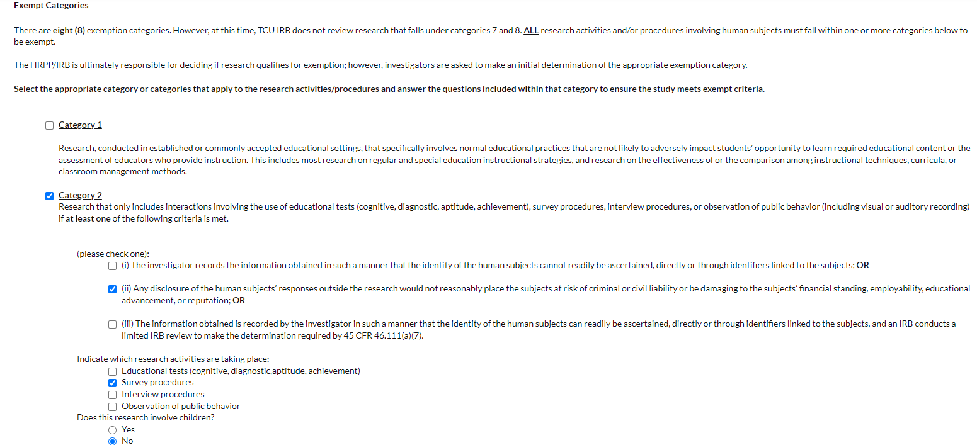

**Changes to the Research Study application:**

Researchers will notice that some areas may have more information or questions due to the most common mistakes or missing information. Our goal was to ensure the application more clearly details what is being asked and provides examples and additional considerations as the study team prepares its application for submission.

The recruitment, informed consent, and study procedures sections will be driven by selecting all recruitment, informed consent, and study procedures methods that will be part of each study. This will encourage our researchers to consider all methods, techniques, and strategies that will be utilized before completing these sections of the application.

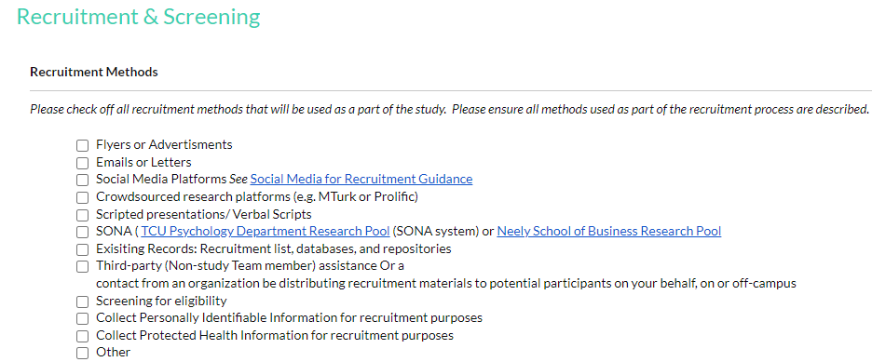

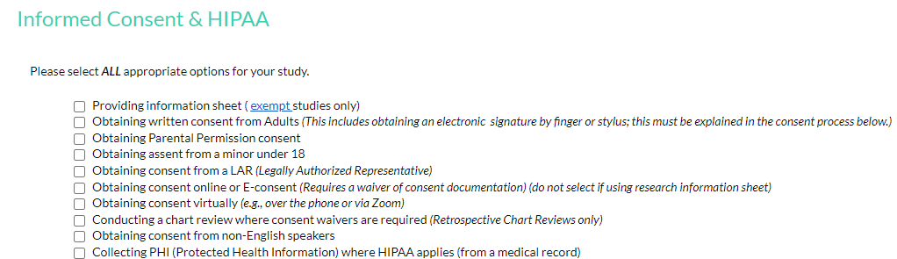

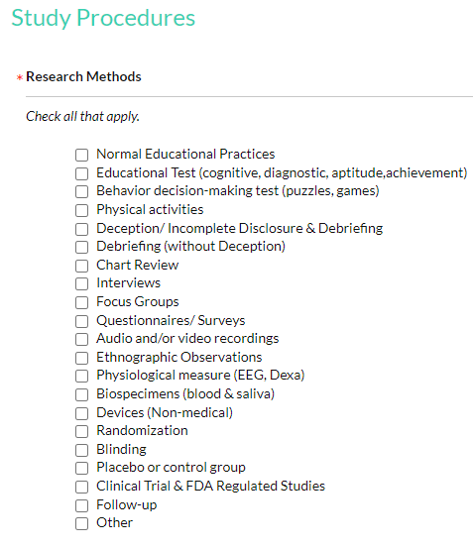

There are also many other changes within the application, so please read through everything carefully. However, it is essentially still the same. Researchers will only see applicable questions and will not have to answer the unnecessary questions in the previous versions.

If you have any questions, feedback, or concerns, please contact us at [IRBSubmit@tcu.edu](mailto:IRBSubmit@tcu.edu).