**How To Set-Up a Study Binder**

**Regulatory Binder Sections**

*It is advised to set-up the study binder in this order. Not all documents will be applicable for every study. Use this document as needed.*

1. **Protocols**
   1. Copies of all versions of the protocol submitted to IRB.
   2. Includes the document that was originally submitted and all subsequent amendments, whether or not the particular version was ever "approved” by the IRB.
   3. Proper versioning and dating of all protocols/ amendments is important in order to distinguish between the various versions.
   4. It is helpful to designate the most current version of the protocol with a sticky note, plastic sleeve, colored paper, or sub-tab to avoid confusion.
   5. Example
      1. 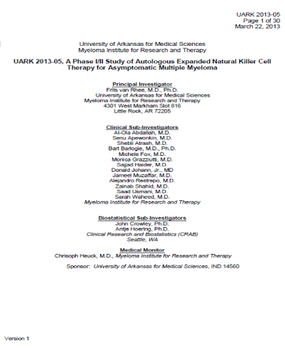
2. **IRB**
   1. Contains all IRB correspondence such as:
      1. Submissions
      2. Approvals and acknowledgements
      3. General correspondence
      4. Official letters
         1. Full Board, Expedited, and Exempt
            1. 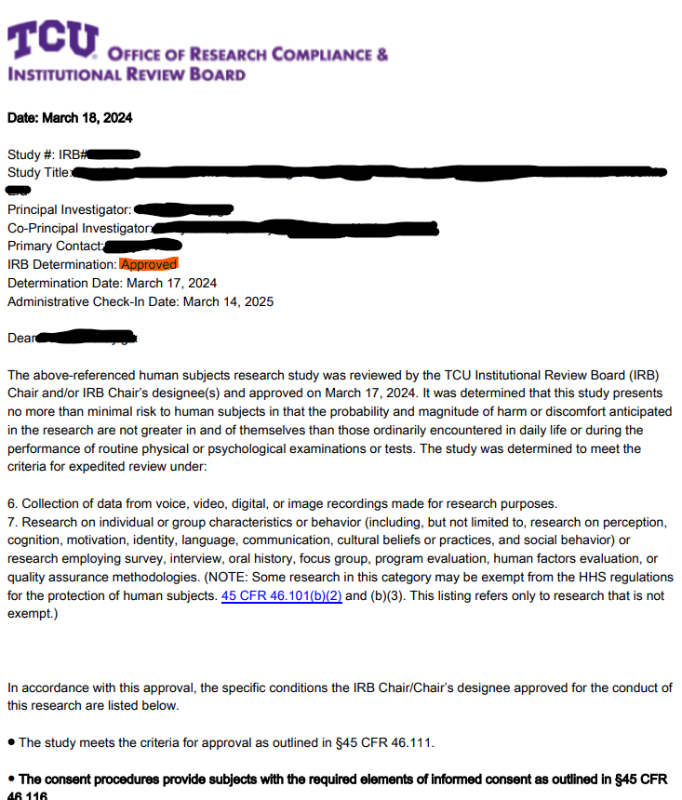
      5. Emails
      6. Faxes
      7. Phone conversation documentation
   2. Consider making separate tabs for IRB submissions (i.e. documents sent to the IRB from the investigator) and IRB letters (i.e. documents sent to the investigator from the IRB) in order to more easily locate documents
3. **Consent and HIPPA**
   1. This section should include copies of all versions of such documents submitted to IRB. This will include the document that was originally submitted and all subsequent amendments whether or not that particular version was ever “approved” by the IRB.
   2. HIPPA Authorization language may be included as part of the consent form and not a separate document.
   3. Like in the protocol section, proper versioning/ dating of all consent forms/HIPPA authorization is important in order to distinguish between the various versions. It is helpful to visibly designate the most current version
4. **Study Staff**
   1. This section includes all the pertinent, up to date information for all individuals in conduct the study such as:
      1. CVs
         1. Should be signed/dated withing 2 years of the start of the study
      2. Medical or professional licenses
      3. Training
         1. CITI Human Subject training
         2. HIPPA
         3. Study-specific training
5. **FDA**
   1. Includes
      1. 1572 Form (drugs)
      2. Investigator Agreement (Devices)
      3. All correspondence to and from FDA
         1. Submissions
         2. Approvals and acknowledgements
         3. Emails
         4. Documentation of telephone conversations
6. **Sponsor Correspondence**
   1. Includes all correspondence to and from the sponsor and / or contract research organization (CRO)
7. **Monitoring**
   1. Includes all monitoring visit reports and Data Safety Monitoring Board (DSMB) correspondence and reports
8. **Product Information**
   1. Includes
      1. Investigators Brochure (IB)
      2. Package inserts
      3. Device Manuals
      4. Sample of product labels
         1. 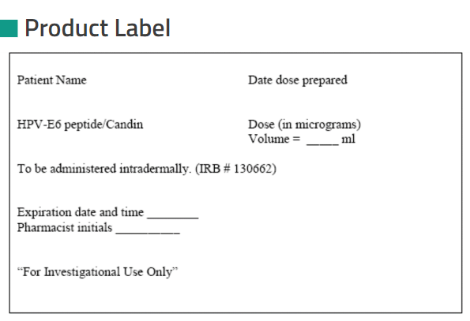
      5. Special instructions for handling the investigational product
9. **Laboratory**
   1. Includes
      1. Current lab certificates
         1. CLIA (Clinical Laboratory Improvement Amendments)
         2. CAP (College of American Pathologists)
      2. Lab normal ranges
      3. Laboratory directors CV
10. **Product Accountability**
    1. Includes
       1. Shipment and receipt records for IP
       2. Destruction records
       3. Accountability and dispensing logs
    2. Info may be kept in research pharmacy
    3. Binders should include documentation of where the records are stored if in an alternate location
11. **Data Collection**
    1. Includes
       1. All versions of sample Case Report Forms (CRFs)
       2. A master randomization list with randomization instructions
       3. Decoding procedures for emergencies
12. **Study Logs**
    1. Includes
       1. Screening log
       2. Subject ID code list
       3. Enrollment log
       4. Delegation of responsibility log
          1. 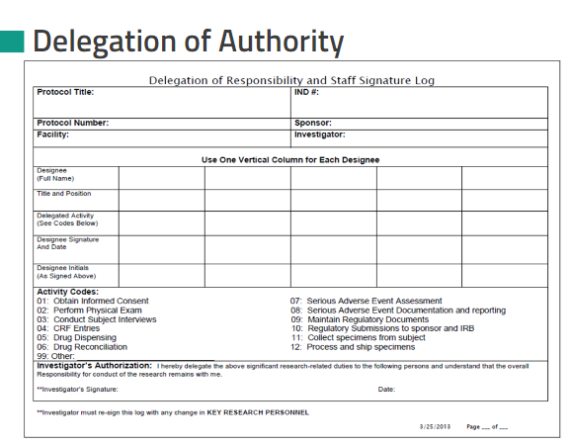
       5. Monitoring visit log
       6. Specimen transfer log