IRB Guidance: Qualtrics Best Practices

Qualtrics is a web-based application that allows you to build, distribute, and conduct survey research without experience. In addition, Qualtrics provides tools that can gather feedback, generate reports, and help you analyze survey responses.

This software is available at no to on-campus departments, including all faculty, staff, and students.

Best Practices for Researchers:

- Principle Investigators (PI)/Faculty mentors of student researchers are strongly encouraged to create surveys using their faculty or staff Qualtrics account rather than having student researchers under their supervision create surveys using their own student accounts. Doing so ensures the PI (faculty mentor) will be able to retain access and control of the survey and resulting data as student researchers come and go from a project. In addition, student Qualtrics accounts are turned off when the students leave their student role at TCU, and it may be difficult for PIs (or anyone else) to gain access to any data stored in the student Qualtrics accounts once they have been deactivated.

Faculty mentors who create surveys in their own Qualtrics accounts can then share each survey (and resultant data) with the applicable student researchers and members of their research team who are authorized research personnel named in the IRB-approved application using the "collaboration" feature in Qualtrics. Students and/or research personnel can perform all the work of entering questions, administering the survey, etc.

- Once data collection is finished and the survey has been closed, the faculty mentor should download the data from Qualtrics and store them securely using TCU Box for electronic storage.
- Once data are downloaded and stored securely outside Qualtrics, the faculty mentor should delete the relevant survey in their Qualtrics account. Only the survey owner can delete the survey from the Qualtrics website.
- Remove access as investigators (faculty or students) are removed from the project.

- If the student researchers create or are currently using surveys developed in their student accounts (not encouraged), the faculty mentor is responsible for ensuring the following:

- The student researchers provide the advisor with access to the survey in Qualtrics using the "Collaboration" feature during the creation of the survey. Students should give their advisors full access as a collaborator. This includes "Edit," "View Reports," "Activate or Close," "Copy," and "Distribute."
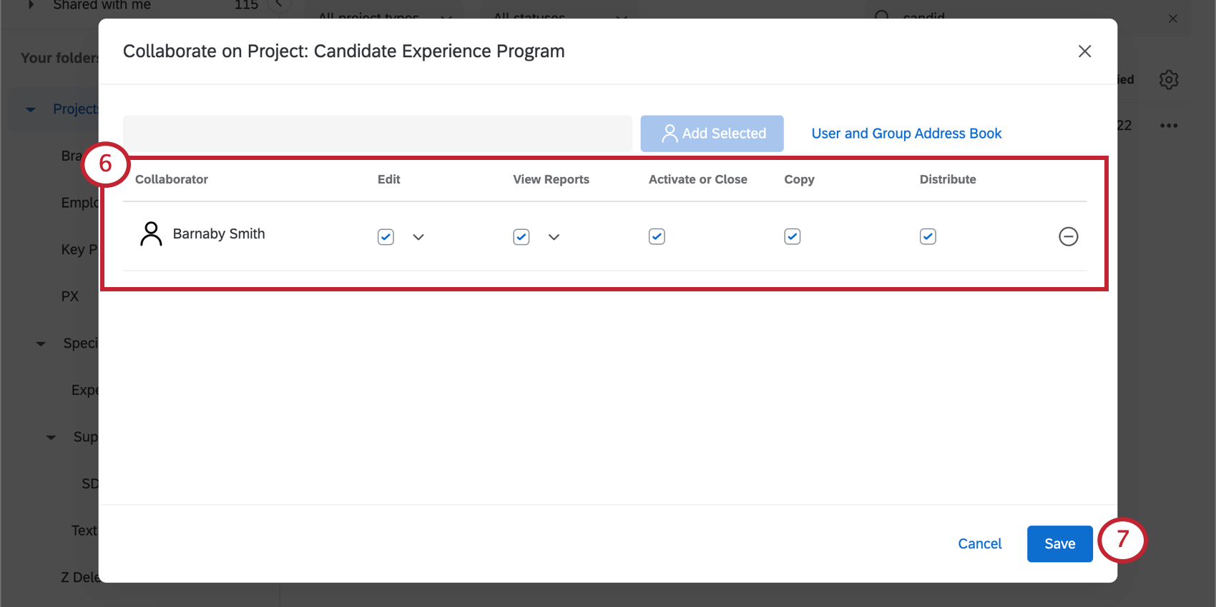
- Once data collection is finished and the survey has been closed, the student researcher downloads the data from Qualtrics, stores them securely using TCU Box electronic storage, and provides the faculty mentor with access to the data.
- Once data are downloaded and stored securely outside Qualtrics, the student researcher deletes the relevant survey in their Qualtrics account. Only the survey owner can delete the survey from the Qualtrics website.

- Once the research study is finished, researchers should not destroy the collected data. Research needs to comply with TCU policy and procedures for the retention of research data.

- Avoid non-compliance due to over-enrollment by limiting the number of surveys initiated/completed (set response limits) in Qualtrics consistent with the target participant accrual approved in your IRB application.

- Qualtrics automatically collects survey participants' IP addresses unless users indicate otherwise in the survey settings. Note that IP addresses are considered a direct identifiers; if the protocol indicates no direct identifiers will be collected. Therefore, survey settings in Qualtrics should be adjusted appropriately (select "Anonymize Response" within Survey Options).

- When obtaining consent within Qualtrics:
  - Include the consent document in a Descriptive Text question. It should be the first question in the survey.
  - Follow the consent document with a multiple-choice question containing:
    - The end language from the consent form (I understand what the study is about, and my questions so far have been answered. I agree to take part in this study).
    - Two answer choices: Agree to Participate and Do Not Agree to Participate
    - Select "Force Response" (under "Response Requirements" in the left-hand navigation pane) so that participants must answer whether or not they agree to participate in order to see the survey.
    - Add skip logic (left-hand navigation pane) so that participants who select Do Not Agree to Participate are sent to the end of the survey, bypassing all questions.
    - Insert a page break after this question so that it appears on the next screen.

