Letter of Support Guidelines and Examples for Conducting Human Subject Research at an External Site or Department

When research is being conducted at an outside institution or organization of any kind, or when the investigator is otherwise relying on the cooperation of another institution, a letter from that institution acknowledging and supporting that relationship is required. A letter of support may also be required when an investigator conducts research in a department other than their own. The organization’s administration should be contacted to determine who is authorized to provide permission. When accessing sites within a larger organization, permission may be required from more than one level of authority.

Required Elements for the Letter

It must be clearly documented for the IRB that someone authorized within the organization (or department or community within a foreign country) is both aware of the research and has granted permission and support for the research. The following is offered as guidance for how a letter can appropriately demonstrate that permission and support for the research has been obtained.

Letter of support must be printed on the facility’s letterhead, signed by the administrator, and include the following:

- A statement that the site administrator has reviewed the research and has found it appropriate for the population of that facility;
- A statement that the site administrator acknowledges the conduct of research activities on site and if applicable, indicating there are appropriate resources available to conduct the research;
- Contact information for an individual who will represent the facility in matter related to the conduct of human subject’s research; and
- A statement that based on the risk associated with the research, there are adequate provisions to handle unanticipated problems and/or adverse events
- Signed and dated by the site administrator, with his/her title below the signature line.

Example #1
Date

Site’s Letterhead
Site’s Name Contacts name Site’s Address

December 18, 2020
Krownedby Kori 3504 Altamesa Blvd
Fort Worth, Texas 76133
Kidney Disease Knowledge and Perceptions of Health in African American Females: udy
Glenda Daniels, PhD, RN
Julianne Swayze, TCU Student Nurse Janie Robinson, PhD, RN
Beauty Shop S

Name of study:
t
Name of study [and TCU IRB # if able]
A
Name of PI:

[input information and role of individuals]

Purpose of the study, acknowledgement of the study being done one site, acknowledgement of the risks (if any) and the understanding of
o the procedures and research methods.

I acknowledge this study and agree to have the investigators recruit participants for the study according to the safety guidelines outlined.
This study aims to look at kidney disease knowledge and perceptions of health in African American females by having participants complete questionnaires. There is no further involvement to participate ther than the completion of the forms. No names will be on any of the questionnaires to maintain confidentiality. The study will adhere to all safety guidelines as outlined in the protocol.
Verbal Support by Krownedby Kori Date: December 18, 2020
Signature of contact Contacts name Date

Example #2
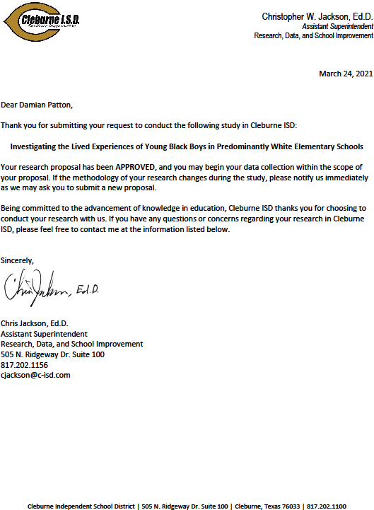
Address of Site & Email of contact
Printed Name

Title
Signature of contact
Title of research and if able, TCU IRB #
Sites footer, usually containing name, address, & phone number
Name of contact

Title
Site’s Letterhead

