PowerForm Signer Information
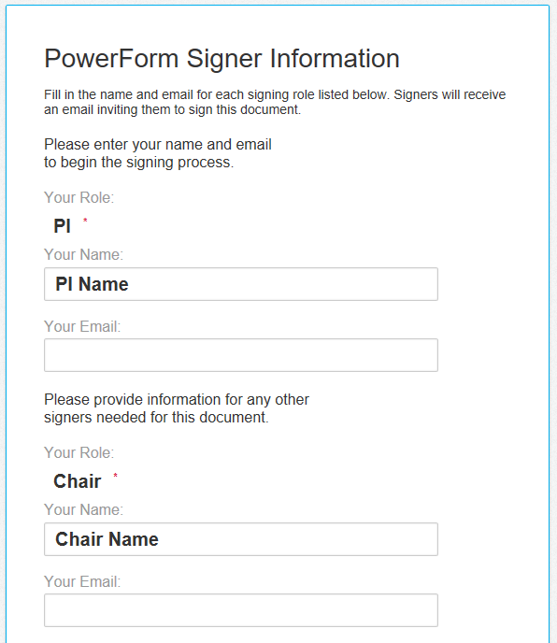

Enter your, the PI’s, name and email
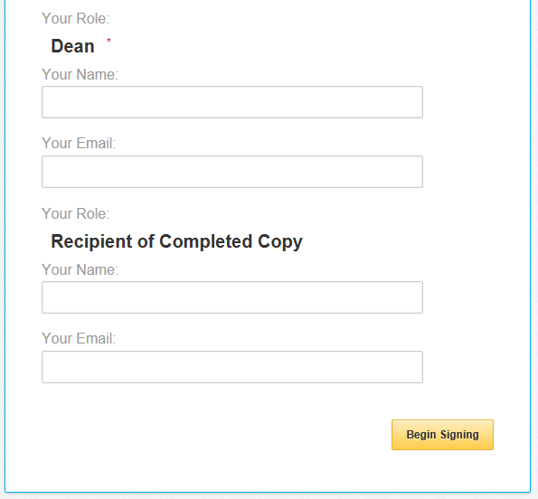
If there is another recipient you would like to receive a completed copy, enter the Recipient’s name and email

Once all fields are entered, select Begin Signing to start completing the form

Enter the Dean’s name and email
Enter the Chair’s name and email

Proposal Information
All fields that are outlined in red are required fields.
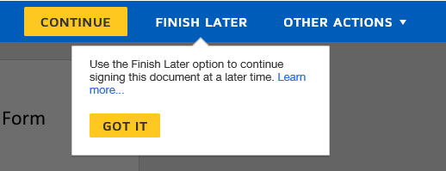
To access the form, you choose “Continue”
PLEASE NOTE --- You must hit Finish Later to save your work if you need to stop the form during completion. If you become inactive for more than 120 minutes the document will log out. Once logged out, there is no way to retrieve completed data.

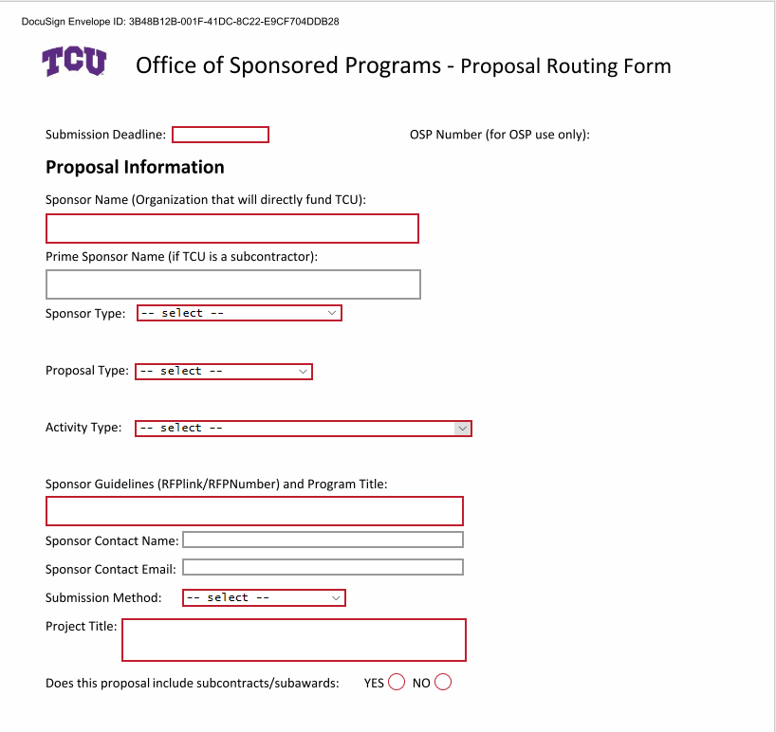

Enter Sponsor Name and Prime Sponsor Name (if applicable)
Select Sponsor Type from the drop-down menu. Definitions can be found on page 7

Select Proposal Type from the drop-down menu. Definitions can be found on page 8

Select Activity Type from the drop-down menu. Definitions can be found on page 8
Enter Sponsor Guidelines link and Program Title
- If necessary, Enter Sponsor Contact Name and Email

Select Submission Method from the drop-down menu.

Enter Project Title as presented on the proposal to be submitted
Select Yes or No in regard to subcontracts/subawards – funds going from TCU to another institution: (If Yes, enter the contact information)
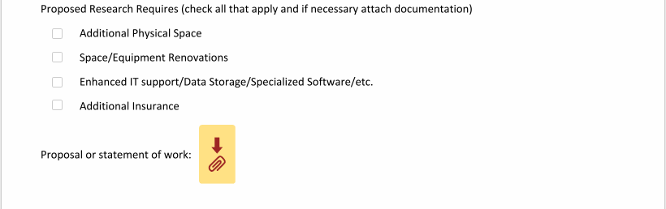
If applicable, select all Proposed Project Requires:
- Additional Physical Space
- Space/Equipment Renovations
- Enhanced IT Support/Data Storage/Specialized Software/etc.
- Additional Insurance

Attach Proposal or Statement of Work

Investigator Information
All fields that are outlined in red are required fields.
The percentage of project distribution should be a representation of the anticipated work performed to complete the entire TCU component of the project amongst TCU PI’s and Co-PI’s. The total project distribution column should equal 100%. The percentage of project distribution should not be confused with your percent of time/effort/pay on the project. Ex. Dr. X is the only TCU PI. She would be responsible for 100% of the work that would be performed at TCU.
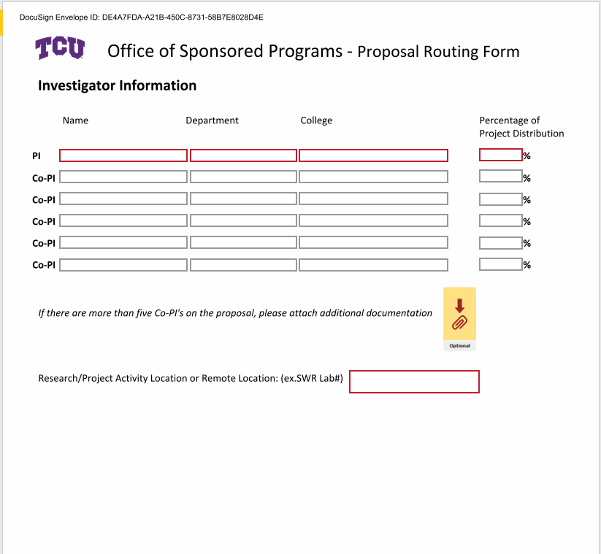

Enter Name, Department, College, and Percentage of Project Distribution for Principal Investigator

If applicable, Enter Co-Investigator Name, Department, College and Percentage of Project Distribution for each Co-Investigator

Enter all Co-Investigators. If there are more than 5 co-investigators, attach a document with all information for the other investigators.

Enter Research/Project Activity Location or Remote Location – this is the location where the actual project/research will be conducted

Budgetary Information
All fields that are outlined in red are required fields.

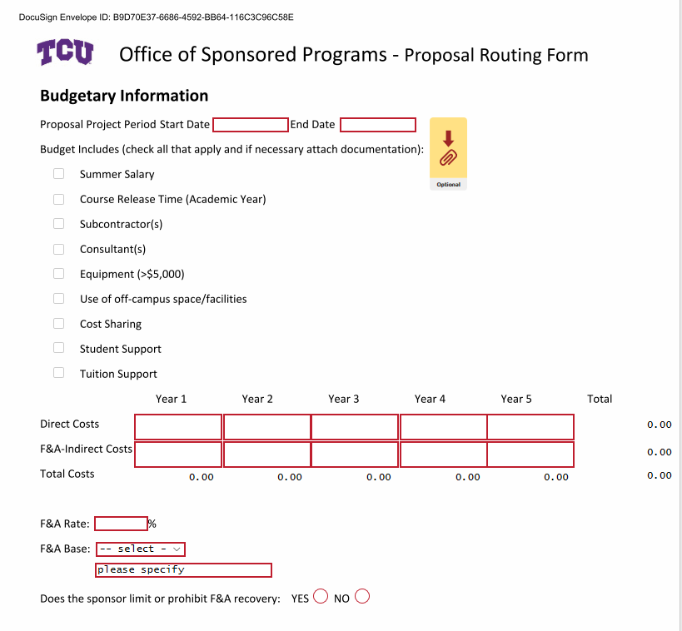

Enter Proposal Project Period Start and End Date

If necessary, attach documentation

Select ALL categories that are applicable to the proposed budget

Enter all Direct Costs and F&A-Indirect Costs for the necessary years

Enter F&A Rate applicable to the proposal budget

Select F&A Base from the drop-down menu. If the base is not on the drop down please specify the base

Select Yes or No for limit or prohibit F&A recovery

Attach Budget using either the TCU budget template or the sponsor format and Budget Justification as required by sponsor

Institutional and Regulatory Compliance Information
All fields that are outlined in red are required fields.

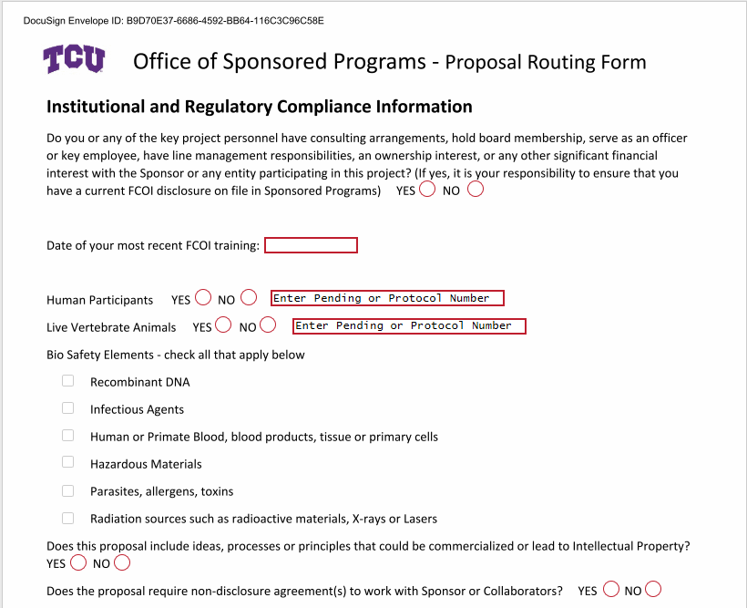

Select Yes or No, for FCOI question

Enter date of most recent FCOI training

Select Yes or No for Human Participants:
Select Yes or No for Live Vertebrate:
- If Yes, enter Pending or Protocol Number in textbox to the right

If applicable, Select all Bio Safety Elements

Select Yes or No for Intellectual Property

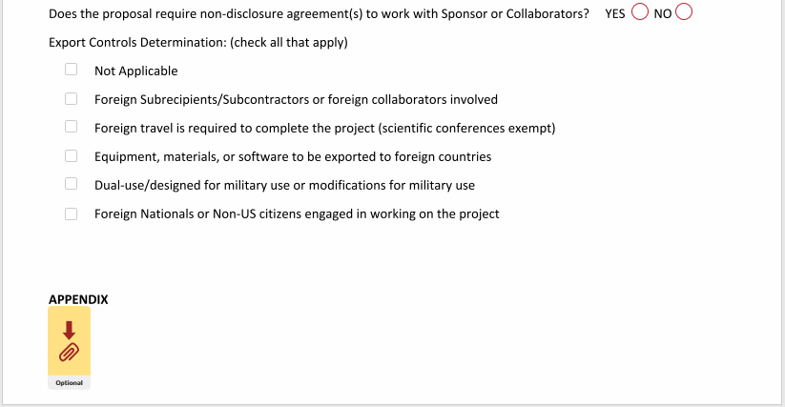
Select Yes or No for Non-Disclosure agreement

Select all Export Controls Determination that apply

Attach Appendix if necessary.

Institutional Approvals and Assurances
All fields that are outlined in red are required fields.
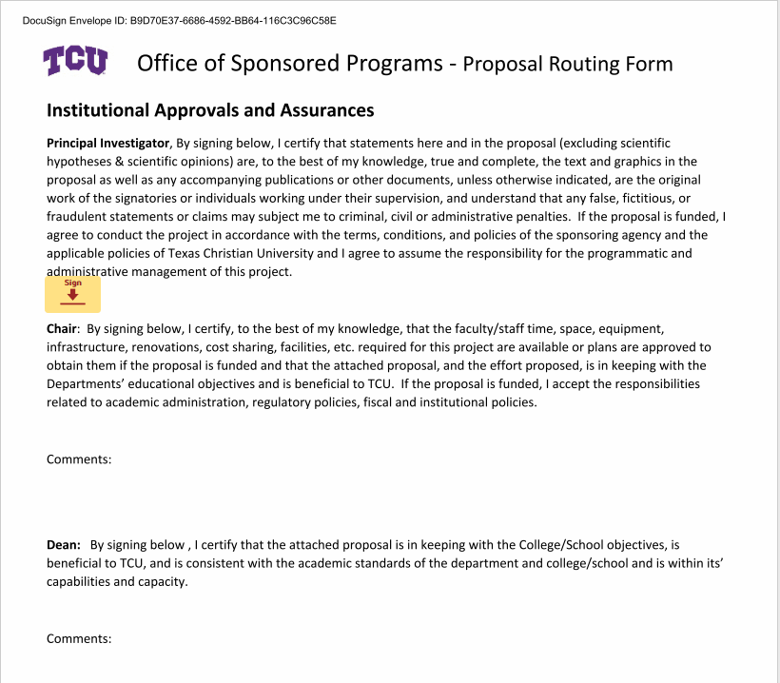

Select Sign to apply your signature.

Once signed, select Finish to begin the approval process.

The form with attachments will be routed to the department chair first. The chair can choose to sign and leave a comment.

The second approval will be routed to the department dean. The dean can choose to sign and leave a comment.

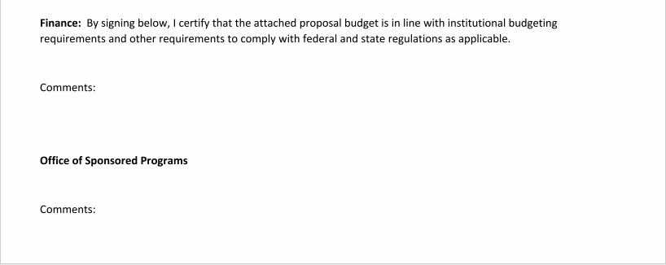
The third approval will be routed to the finance department. The director of research accounting can choose to sign and leave a comment.

The final approval will be routed to the Associate Provost for Research. It will be reviewed, commented, and approved/denied.

References
Sponsor Type:
Federal
- The Federal financial assistance that a non-Federal entity receives directly from a Federal awarding agency or indirectly from a pass-through entity, as described in § 200.101 Applicability of the OMB Uniform Grant Guidance; or (2) The cost-reimbursement contract under the Federal Acquisition Regulations that a non-Federal entity receives directly from a Federal awarding agency or indirectly from a pass-through entity, as described in § 200.101 Applicability of the OMB Uniform Grant Guidance.
Federal Pass through
- Funds issued by a federal agency to another entity (a state agency, institution or company) that are then transferred to other entities per the award eligibility terms. The original award entity is referred to as the "prime recipient" of the pass-through funds. The secondary entities are referred to as "sub recipients."
Texas State Agency- Any Texas state Agency or instrumentality thereof exclusive of local governments.
Other State Government
- Any state of the United States, the District of Columbia, the Commonwealth of Puerto Rico, the Virgin Islands, Guam, American Samoa, the Commonwealth of the Northern Mariana Islands, and any agency or instrumentality thereof exclusive of local governments.
Local Government
- Any unit of government within a state, including a: (a) County; (b) Borough; (c) Municipality; (d) City; (e) Town; (f) Township; (g) Parish; (h) Local public authority, including any public housing agency under the United States Housing Act of 1937; (i) Special district; (j) School district; (k) Intrastate district; (l) Council of governments, whether or not incorporated as a nonprofit corporation under state law; and (m) Any other agency or instrumentality of a multi-, regional, or intra-state or local government.
Private Non-Profit
- Any corporation, trust, association, cooperative, or other organization, not including IHEs, that: (1) Is operated primarily for scientific, educational, service, charitable, or similar purposes in the public interest; (2) Is not organized primarily for profit; and (3) Uses net proceeds to maintain, improve, or expand the operations of the organization.
Corporate/Private Industry
- Corporate or industry contracts generally involve a quid pro quo, i.e., something is given and something is received
Foreign/International
- An organization that identifies itself as international or intergovernmental, and has membership from, and represents the interests of, more than one country, without regard to whether the headquarters of the organization and location of the activity are inside or outside of the United States

Proposal Type:
New
- A proposal submitted to a sponsor for the first time, or a proposal being resubmitted after having been declined by a potential sponsor. (NSF considers every submission new)
Resubmission
- This modifies a proposal that may be pending or is otherwise unfunded, and is being submitted to address prior proposal reviewer comments or add additional elements.
Renewal
- Proposals which request continued support for an existing project that is about to end. These requests--from the sponsor's viewpoint--generally have the same status as an unsolicited proposal.
Competing continuation
- These confirm the original proposal and funding requirements of a multi-year project which the sponsor has already provided funding for an initial period (normally one year). Continued support is usually dependent on satisfactory work progress and the availability of funds.
Supplement
- A supplemental asks for an increase in support for a proposal that has already been funded. The requested increase would occur in the current budget period and may involve a broadening of the project's approved scope. Since additional funding is requested, a new budget is required.
Activity Type:
Basic Research
- Systematic study directed toward fuller knowledge or understanding of the fundamental aspects of phenomena and of observable facts without specific applications towards processes or products in mind. Basic research is mostly conducted to enhance knowledge.
Applied Research
- Systematic study to gain knowledge or understanding necessary to determine the means by which a recognized and specific need may be met. Applied research focuses on analyzing and solving real-life problems. This type of research refers to the study that helps solve practical problems using scientific methods.
Evaluation/Assessment
- Process of collecting, reviewing and using data, for the purpose of improvement in the current performance. Evaluation is described as an act of passing judgement on the basis of set of standards
Creative Activity
- Such as artistic training and performances.
Public Service
- A project where the primary purpose is to provide a service rendered in the public interest or geographically extends the resources of the institution to entities or persons otherwise unable to take advantage of such resources.
Professional Development/Instruction/Training
- Activities involving training of individuals in research techniques where training is in the same facility as other research & development. Example: NIH Research Training Grants (T series). Non-research related instruction, including conferences & workshops, where primary purpose is training & development of students & personnel.
Curriculum/Program Development
- Systematic use of knowledge or understanding gained from research directed toward production of useful materials, devices, systems, or methods, including design & development of prototypes & processes. Examples: SBIR, STTR, Phase III (can include Phase II if FOA specifies for development stage
Fellowship/Scholarship
- Undergraduate fellowships focused on training in research techniques. Examples: NIH, HRSA, AHA Individual Fellowships (F series), CDC Public Health Fellowship Opportunities. Graduate fellowships focused on training in research techniques. Examples: NIH, HRSA, AHA Individual Fellowships (F series
Equipment Only
- Tangible or intangible property that can be used or consumed for more than one year, with a unit price of $5,000 or more. These items should be included as equipment in the Budget and are excluded from modified total Direct Costs (MTDC).
Clinical Research
- Any experiment that involves a test article and one or more individuals who participate, either as a recipient of the test article or as a control; and that either is subject to requirements for prior submission to the FDA under sections 505(i) or 520(g) of the Food, Drug and Cosmetics Act, or is not subject to requirements for prior submission to the FDA under these sections of the Food, Drug and Cosmetics Act, but the results of which are intended to be submitted later to, or held for inspection by, the FDA as part of an application for a research or marketing permit (21 CFR 50.3)

